**CHANDIGARH UNIVERSITY**

**University Institute of Computing**

**Gharuan, Mohali (140413)**

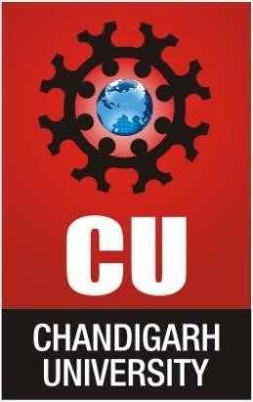

**A Mini-Project Report** **On**

**"Prepare a poster to advertise an event”**

**[23CAP-204]**

**Desktop Publishing Lab**

**Submitted by**

**Nikhil Dhaka (23BCA10411)**

**Submitted to** Riya Mondal(E17321)

**Department of Bachelor of Computer Applications**

**Table of Contents**

CHAPTER 1 : Aim/ Overview of the practical 1

1.1 Introduction /objectives 1

CHAPTER 2: Technologies and Tools 2

2.1 Adobe Photoshop 2

2 .2 Typography 3

2 .3 Colour Scheme 3

2 .4 Graphics and Icons 4

CHAPTER 3: Project Features 4

CHAPTER 4: Designing Process 5

Step 1: Setting up the Document 5

Step 2: Creating the Background 5

Step 3: Adding Text for the Event 6

Step 4: Inserting Graphics 6

Step 5: Using Shapes for Design Enhancements 7

Step 6: Applying Layer Styles 7

Step 7: Final Adjustments 8

Step 8: Exporting the Poster 8

Final Outcome: 9

CHAPTER 5: Challenges Faced 9

5.1 Technical Difficulties with Software 10

5.2 Alpha-Beta Pruning 10

5.3 Color Selection and Contrast 10

5.4 Time Management 10

1CHAPTER 6: Future Improvements 10

CHAPTER 7: CONCLUSION 11

# 

**Aim/Overview of the Practical:**

The aim of this project was to create an engaging and informative event poster using Adobe Photoshop. The main objectives included designing a visually appealing layout that highlights key event details—such as the event name, date, time, and location—while enhancing technical skills in Photoshop. This practical provided hands-on experience with various Photoshop tools, such as layers, text, shape tools, and layer styles, to develop an effective and balanced design that captures the viewer’s attention and communicates essential information clearly.

# CHAPTER 1.1: INTRODUCTION /OBJECTIVES

### This project focuses on creating an engaging event poster using Adobe Photoshop, aimed at capturing the attention of a target audience. The main objective was to design a visually appealing and informative poster, incorporating essential event details such as the name, date, time, and venue. Adobe Photoshop was selected for its extensive range of design tools and customization options, allowing for professional-quality outcomes. This project also served as a practical learning experience, helping me become familiar with Photoshop’s key tools, such as the text tool, shape tool, and layer styles, to achieve a balanced and attractive layout.

### OBJECTIVES

1. **To Design an Effective Poster**: Create a visually appealing poster that effectively communicates the event details, attracting the attention of potential attendees.
2. **To Utilize Adobe Photoshop Tools**: Learn and apply various Adobe Photoshop tools and features, such as the text tool, shape tool, and layer styles, to enhance the design quality.
3. **To Establish Information Hierarchy**: Organize the event information in a clear hierarchy, ensuring that the most important details, like the event title, are prominently displayed.
4. **To Experiment with Color and Typography**: Explore different color schemes and font styles to find the best combinations that enhance the overall design while maintaining readability.
5. **To Develop Technical Skills**: Improve technical skills in graphic design by completing the poster project from concept to final export, gaining practical experience in creating digital artwork.

# CHAPTER 2: Technologies and Tools

### 2.1 Adobe Photoshop

* Adobe Photoshop was the primary software used to design the poster, offering robust graphic editing tools essential for creating and refining images. Key features applied in this project included:

**Layers:** Layers allowed for organized management of each design element, making it possible to make adjustments without impacting the entire composition.

**Text Tool:** This tool was crucial for adding and formatting text elements like the event title and other details, providing flexibility in style and placement.

**Shape Tool:** Used to create banners and highlights behind text, the shape tool helped enhance the poster's visual impact and focus on important information.

**Layer Styles:** Effects like drop shadows and strokes were added to text and shapes, providing depth and making key elements more noticeable.

## 2 .2 Typography

* Typography played a crucial role in the design of the poster, significantly influencing both readability and visual appeal. The following factors were considered for this project:

• **Font Selection:** A mix of bold and regular fonts was utilized to establish a clear information hierarchy. For instance, the event title was rendered in a bold font to draw attention, while the date and venue details were displayed in a simpler font to ensure clarity.

• **Font Sizes:** Various font sizes were implemented to distinguish between headings and body text, using larger sizes for essential details and smaller sizes for less critical information.

• **Text Color:** The color choices were made to provide a strong contrast against the background, guaranteeing that all text remains easily legible.

## 2 .3 Colour Scheme

A thoughtfully chosen color scheme was applied to elevate the visual appeal of the poster and ensure consistency throughout the design. Key elements included:

* **Background Colors:** A gradient background was designed using complementary colors to attract attention and establish the overall atmosphere of the poster.
* **Text Colors:** The colors selected for the text were aimed at providing a strong contrast with the background, ensuring that the information is clear and easily readable.
* **Graphic Colors:** Additional colors for graphics and shapes were picked to align with the event’s theme and overall color palette, contributing to a unified and harmonious appearance.

## 2 .4 Graphics and Icons

Graphics and icons played a vital role in enhancing the visual attractiveness of the poster. The following elements were included:

Logos: The event logo was placed prominently to strengthen brand identity and improve recognition of the event.

Decorative Icons: Icons were utilized to highlight important details, such as the date and location, making the information more engaging and visually appealing.

Image Formats: High-resolution images were employed to ensure clarity and avoid pixelation in both print and digital displays.

# CHAPTER 3: Project Features

**Clear and Intuitive Layout**: The layout of the poster was crafted to facilitate easy readability, with all event details organized in a logical manner.

**Information Hierarchy**: A distinct hierarchy is established within the poster, with the event title as the most prominent element, followed by the date, time, and venue.

**Visually Engaging Design:** The combination of complementary colors, bold typography, and graphics contributes to the poster's attractiveness, ensuring it effectively captures the audience's attention.

**Adaptable Design:** While primarily designed for print, the poster can also be easily modified for digital use by adjusting the export settings**.**

**Custom Graphics and Shapes**: The Shape Tool was employed to add shapes, creating banners that emphasize important details within the design.

**Enhanced Layer Styles:** Effects like drop shadows, strokes, and gradients were applied to both text and graphics to make key information more prominent.

# CHAPTER 4: Step 1: Document Setup I started by opening Adobe Photoshop and creating a new document for the poster. The selected dimensions were 1080 x 1350 pixels for social media posts and A4 (210mm x 297mm) for print. The resolution was adjusted to 300 DPI for high-quality print and 72 DPI for digital use.

# Steps:

# Navigate to File > New

# Set the width, height, resolution, and color mode (RGB for digital, CMYK for print).

# Step 2: Background Creation

# I initially applied a solid color background using the Paint Bucket Tool, which was later enhanced with a gradient effect to add visual depth. The gradient was applied diagonally, transitioning from light to dark.

# Steps:

# Select the Gradient Tool.

# Choose two colors (e.g., blue and white).

# Drag from one corner of the canvas to apply the gradient.

# Step 3: Adding Event Text Using the Text Tool (T), I added the title, date, time, and venue to the poster. The event title was set in a larger font size (48pt), while other details were smaller (24pt) to create a clear hierarchy.

# Steps:

# Click on the canvas to type the title.

# Adjust the font, size, and color using the top toolbar.

# Use bold fonts for the title and regular fonts for the event details.

# Step 4: Inserting Graphics To add dynamism to the poster, I included a logo using the Place Embedded option. The logo was positioned prominently at the top, with additional icons placed around the text.

# Steps:

# Go to File > Place Embedded.

# Select the image file (e.g., logo or decorative elements).

# Resize and reposition it using Ctrl + T.

# Step 5: Utilizing Shapes for Enhancement I employed the Shape Tool (U) to create banners behind the text, helping to highlight important details. These shapes were filled with contrasting colors to improve visibility against the background.

# Steps:

# Select the Shape Tool and choose either a rectangle or ellipse.

# Draw the shape on the canvas and adjust the color using the Fill option in the top toolbar.

# Step 6: Applying Layer Styles To enhance the text’s visibility, I applied Drop Shadows and Stroke effects, which added depth and made the text more readable against the background.

# Steps:

# Right-click on the text layer.

# Select Blending Options.

# Apply Drop Shadow and Stroke, adjusting settings as necessary.

# Step 7: Final Adjustments Before exporting the poster, I ensured that all elements were correctly aligned using rulers and guides, which helped maintain a balanced and polished design.

# Steps:

# Navigate to View > Rulers.

# Drag guides onto the canvas to align text and images.

# Step 8: Exporting the Poster The final poster was exported in two formats: JPEG for web use and PDF for printing, with the print resolution set to 300 DPI to ensure quality.

# Steps:

# Go to File > Export As.

# Select the format (JPEG for web or PDF for print).

# Final Outcome:

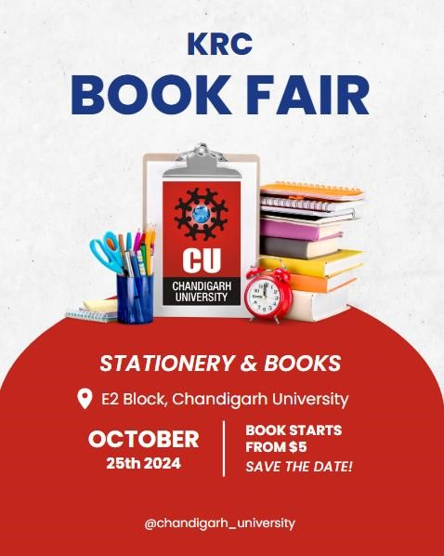

**CHAPTER 5: Challenges Encountered**

**5.1 Technical Issues with Software:**As a beginner, I found navigating Adobe Photoshop to be quite daunting. I faced difficulties with layer management and understanding blending modes. To overcome this, I implemented a naming system for my layers and experimented with various blending options while consulting online tutorials for guidance.

**5.2 Layout and Design Balance:**Achieving a well-balanced layout proved to be challenging, especially when it came to aligning elements and creating a clear information hierarchy. I made use of Photoshop's grid and guide features to enhance alignment, and I created mock-ups to explore different design arrangements.

**5.3 Color Choice and Contrast:**Selecting a color scheme that was visually appealing while ensuring readability was a significant challenge. I utilized color palette generators to identify complementary colors and made frequent adjustments to color values to maintain a strong contrast between the text and background.

**5.4 Managing Time Effectively:**Juggling this project alongside other commitments posed time management challenges. I initially underestimated the time required for each phase, which resulted in a hurried final review. To enhance my planning, I developed a timeline that detailed specific tasks and deadlines to keep me on track.

# CHAPTER 6: Future Improvements

Upon reflecting on this project, several areas have been identified for improvement that could enhance both the design process and the final outcome in future endeavors. In upcoming projects, I intend to allocate more time to the initial design planning stage, including the creation of detailed sketches or wireframes before diving into Photoshop. Establishing a clearer vision from the start will facilitate a smoother design process and reduce the need for revisions. Although I utilized color palette generators, I recognize that exploring a broader range of color combinations could yield more visually striking results. In future work, I will set aside time to experiment with and test various color schemes to gain a deeper understanding of their effects on overall design.

**CHAPTER7:CONCLUSION**  
In summary, the experience of creating an event poster using Adobe Photoshop has been an invaluable learning opportunity that has allowed me to enhance my design abilities and acquire practical knowledge of graphic design principles. Throughout this process, I faced numerous challenges, including navigating software tools, achieving a balanced layout, and selecting appropriate colors. These challenges motivated me to develop my problem-solving skills and seek out resources for improvement.

The feedback I received during the project offered insights into how my design was viewed by others, underscoring the significance of collaboration in the creative process. Moving forward, I aim to implement structured feedback mechanisms and further refine my technical skills in Photoshop to produce even more effective designs.

Overall, this project has enriched my understanding of design and inspired me to keep exploring the creative potential within graphic design. The skills and knowledge I have gained will undoubtedly support my growth as a designer, empowering me to approach future projects with greater confidence and creativity.